# This is some specification

## Introduction

This specification describes the Universal Army Potato. The Universal Army Potato (UAP) is a fierce and fearsome weapon that can be used against enemy infantry.

Despite its biological nature, it is not governed by any International Treaties that are in force as of writing this document.

## Potato Static Architecture

The following chapter describes the Static Architecture of the Universal Army Potato. The overall architecture is presented in Figure 1.

* 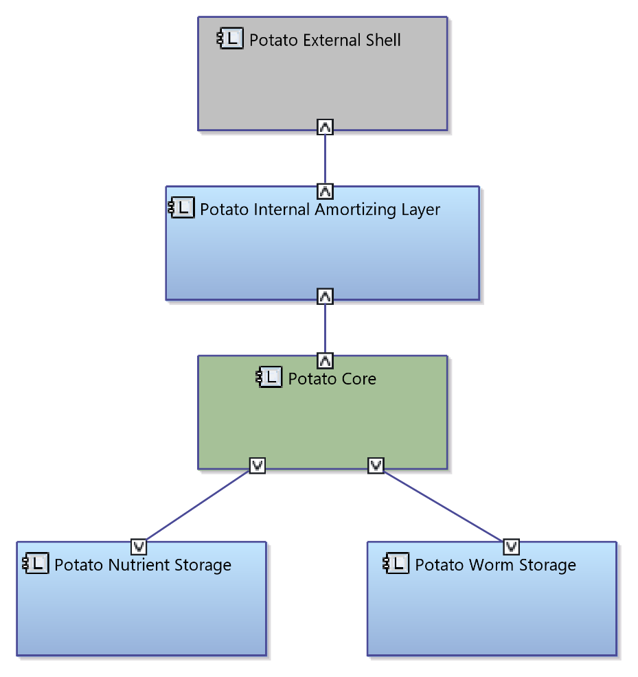

Figure 1 Universal Army Potato static architecture

The presented figure makes absolutely no sense, just as the Universal Army Potato procurement.